Bajaj Special Classes Notes - By Neeraj Sir

Important Leetcode Questions for Bajaj - 2, 19, 141, 142, 206, 21, 24, 61, 92, 138.

DSA Questions For Bajaj:-
https://docs.google.com/spreadsheets/d/1UT-We4vMUdFDuq2SbUJU6zPWEnxeTyM9/edit?usp=drive_link&ouid=103866424956525699767&rtpof=true&sd=true

Placement Oriented Questions and Roadmap

100 DSA Questions
https://docs.google.com/spreadsheets/d/1lzd3x8lKLHRngzndgRk9pNtEPc0p5szHxLQi5K6pR3g/edit?usp=drive_link

1. Complete Topic Coverage
Week 1
- Arrays & Strings fundamentals (traversal, operations, time complexity)
- Two Pointers and Sliding Window techniques
- Prefix Sum, Suffix Sum, Equilibrium (Pivot) Index, Split Array
- Linear Search and Binary Search
- Kadane’s Algorithm for Maximum Subarray Sum
- Basic Java concepts and OOP fundamentals (Encapsulation, Inheritance, Polymorphism, Abstraction)
Week 2
- ArrayList (dynamic resizing and operations) + Circular Array
- Maximum Subarray Sum in Circular Array
- Advanced String manipulation (traversal, frequency counting, two-pointer, edge cases)
- LeetCode problems: Ransom Note, Valid Anagram, Reverse String, Valid Palindrome
- Permutations using Recursion and Backtracking
- LPS (Longest Proper Prefix which is also Suffix)

Week 3
- Advanced String problems + HashMap introduction (frequency counting, operations)
- HashMap-based problems with multiple approaches
- Recursion & Backtracking (base cases, stack behavior, Subsets, Fibonacci)
- Exception Handling in Java (try-catch-finally, throw/throws, built-in vs user-defined)

Week 4
- Linked Lists (Singly, Doubly, Circular): reversal, middle node, Floyd’s Cycle Detection, merge, remove Nth node from end
- Comprehensive Java revision (OOP, memory concepts, exception handling)
Week 5
- Intensive problem-solving on Linked Lists and Stacks
- Stack applications: Next Greater Element, Stock Span, Valid Parentheses, backspace, adjacent duplicates, Baseball Game
- Binary Trees: structure, Preorder/Inorder/Postorder Traversal, Invert Tree, Maximum Depth, Same Tree, Symmetric Tree
- Abstract Classes in Java

2. 4-Week Structured Revision & Practice Plan
Implement all solutions in Java. Follow the course pattern:
- Theory revision → Paper dry run → Coding → Optimization → Complexity analysis
- Solve 3–4 problems daily
Maintain a personal tracker: Topic | Week Covered | Confidence Level | Problems Solved | Revision Date
Week 1: Arrays, Strings, Searching & Kadane’s
Focus: Two Pointers, Sliding Window, Prefix/Suffix Sum, Equilibrium Index, Linear/Binary Search, Kadane’s (linear + circular), String techniques.
Practice Priority: Searching, Prefix/Sum logic, Sliding Window, Two Pointers, Kadane’s.
Week 2: HashMap, Recursion/Backtracking, Exception Handling & ArrayList
Focus: HashMap problems, Permutations, LPS, Recursion, Exception Handling, ArrayList.
Practice Priority: String & Hashing, Two Sum, Recursion/Backtracking.
Week 3: Linked Lists & Stacks
Focus: All Linked List operations (reverse, cycle detection with Floyd’s slow-fast pointers, remove Nth, swap pairs) + Stack problems (Next Greater, Stock Span, parentheses, backspace, adjacent duplicates).
Practice Priority: Linked List and Stack sections.

Week 4: Binary Trees, Java OOP & Mixed Revision
Focus: Tree traversals, Invert Tree, Max Depth, Same Tree, Symmetric Tree + OOP concepts (Inheritance, Overloading/Overriding, Encapsulation, Getters/Setters, Abstract Classes, Access Modifiers).
Practice Priority: Binary Tree problems + Java OOP.
Final days: Mixed problems + full mock test (8–10 problems from all topics).
Daily Habit
- Revise theory with dry runs on paper.
- Code in Java.
- Analyze edge cases and optimize.
- Note time & space complexity.

3. Categorized Practice Problems
Solve all problems in Java. Prioritize in the given order.
1. Searching Algorithms
- Linear Search, Binary Search (LeetCode 704)
- Search Insert Position (LeetCode 35)
2. Prefix/Suffix & Array Logic
- Prefix/Suffix Sum array, Equilibrium Index, Range Sum Queries, Split Array
3. Sliding Window & Two Pointers
- Maximum sum subarray of fixed size, Longest substring with constraints, Valid Palindrome variants
4. Kadane’s Algorithm
- Maximum Subarray Sum, Maximum Sum in Circular Array
5. String & Hashing
- Reverse String (LeetCode 344)
- Valid Anagram (LeetCode 242)
- Ransom Note (LeetCode 383)
- Valid Palindrome (LeetCode 125)
- Find the Index of the First Occurrence in a String (LeetCode 28)
- Make The String Great (LeetCode 1047)

6. Recursion / Backtracking
- Generate all Subsets, Fibonacci (LeetCode 509), Permutations
7. Stack Problems
- Next Greater Element, Stock Span Problem
- Valid Parentheses (LeetCode 20)
- Baseball Game (LeetCode 682)
- Backspace String Compare (LeetCode 844)
8. Linked List Problems
- Remove Nth Node From End (LeetCode 19)
- Detect Cycle Start (LeetCode 142)
- Swap Nodes in Pairs (LeetCode 24)
- Palindrome Linked List (LeetCode 234)
9. Binary Tree Problems
- Preorder Traversal (LeetCode 144)
- Inorder Traversal
- Invert Binary Tree (LeetCode 226)
- Maximum Depth of Binary Tree (LeetCode 104)
- Same Tree (LeetCode 100)
- Symmetric Tree (LeetCode 101)
10. Java OOP & Miscellaneous
- Inheritance, Method Overloading/Overriding, Encapsulation (Getters/Setters)
- Exception Handling (try, catch, throw, finally)
- Abstract Classes, Access Modifiers
Additional Problems
- LeetCode 1 (Two Sum), 21 (Merge Two Sorted Lists)
- Various BST problems (LeetCode 230, 530, 938, etc.)
- DNA sequence problem (10-letter sequences occurring more than once)
Target: Complete all listed problems over the 4 weeks.

4. Key Techniques Quick Reference
- Kadane’s Algorithm: Track current and maximum sum; reset when negative. For circular: compare linear max vs (total sum – min subarray sum).
- Floyd’s Cycle Detection: Slow pointer (1 step), Fast pointer (2 steps). If they meet, cycle exists; reset one pointer to head to find starting node.
- HashMap for Strings: Use for frequency counting in anagrams and ransom note problems.
- Two Pointers on Strings: Ignore non-alphanumeric characters and compare lowercase from both ends for palindrome check.
- Recursion: Always define a clear base case; manage stack and backtrack when needed.

5. Guidelines for Success
- Maintain consistency with daily practice (3–4 problems per day).
- Emphasize dry runs on paper before coding.
- Implement everything in Java and revise OOP & Exception Handling alongside DSA topics.

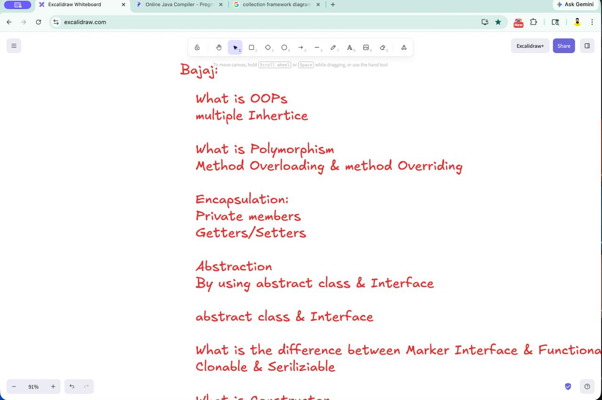
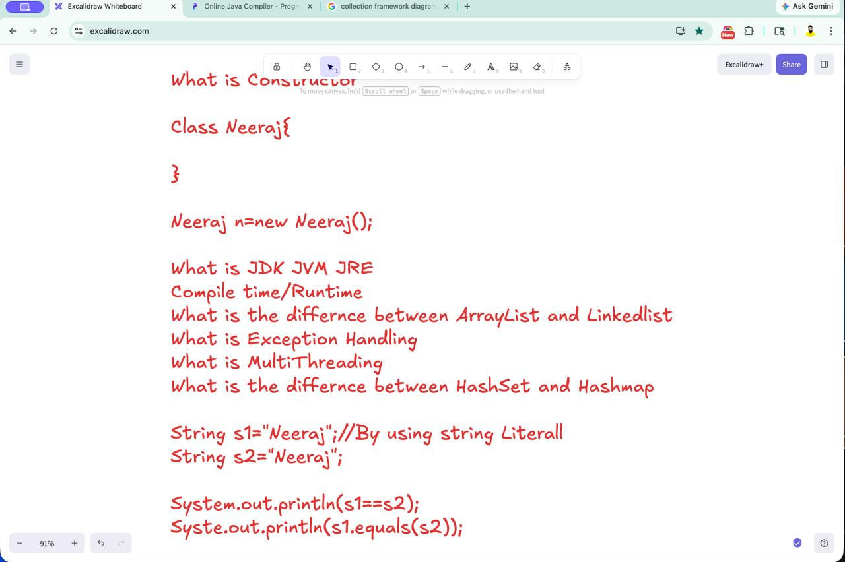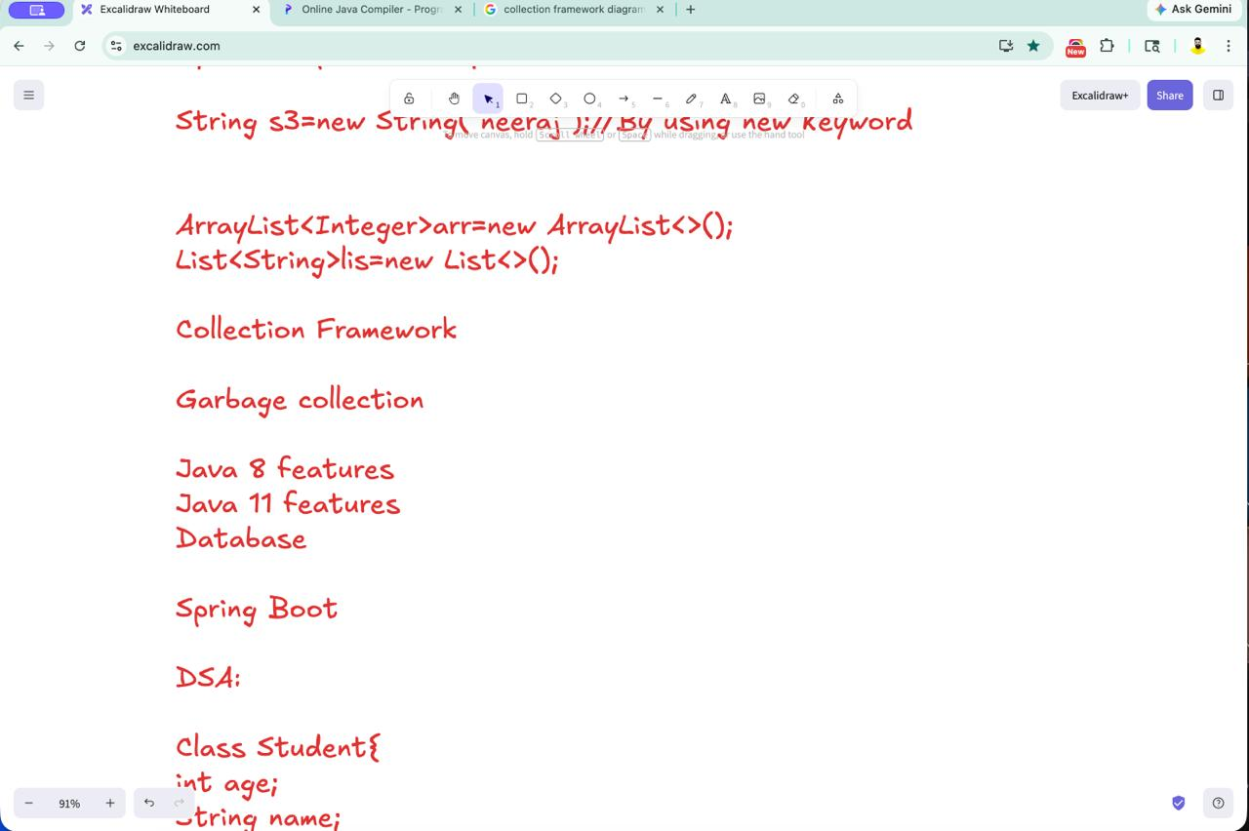
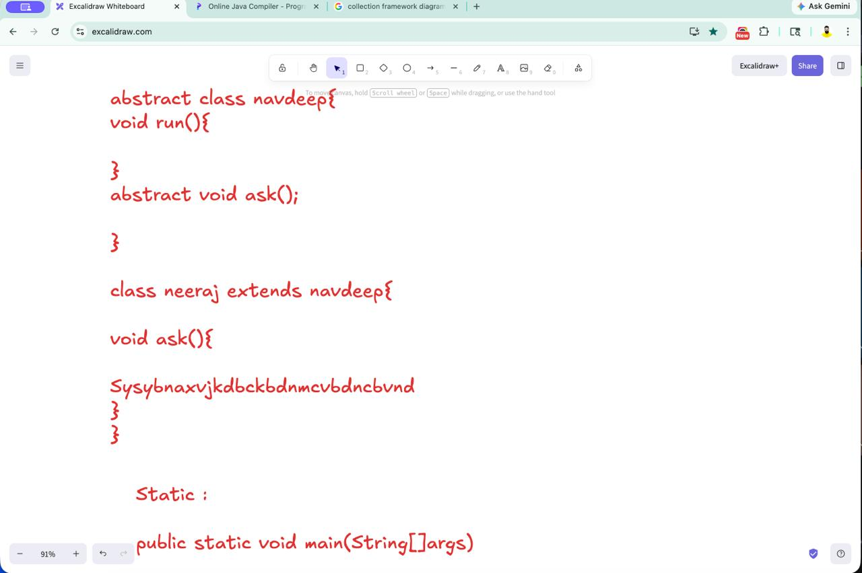

/////////////////////////////////////////////////////////////////////////////////////////////////////////////// 08/04/2026

// Online Java Compiler
// Use this editor to write, compile and run your Java code online
class Node{
int data;
Node next;
Node(int data){
this.data=data;
this.next=null;

}
}
class Main {
public static Node reverse(Node head){
Node prev=null;
Node curr=head;
while(curr!=null){
Node next=curr.next;
curr.next=prev;
prev=curr;
curr=next;

}
return prev;
}
public static void printList(Node head){
Node temp=head;
while(temp!=null){
System.out.println(temp.data+"->");
temp=temp.next;

}
System.out.println("NULL");
}
public static void main(String[] args) {
// System.out.println("Try programiz.pro");
//1..2...3...4...null
//4...3....2...1..null
Node head=new Node(1);
head.next=new Node(2);
head.next.next=new Node(3);
head.next.next.next=new Node(4);
System.out.println("original List");
printList(head);
head=reverse(head);
System.out.println("reversed:");
printList(head);

}
}

// Online Java Compiler
// Use this editor to write, compile and run your Java code online
import java.util.*;
class Main {
// public static int[] twoSum(int[]arr,int target){
// HashMap<Integer,Integer>map=new HashMap<>();
// for(int i=0;i<arr.length;i++){
// int comp=target-arr[i];
// if(map.containsKey(comp)){
// return new int[]{map.get(comp),i};
// }
// map.put(arr[i],i);
// }
// return new int[]{-1,-1};
// }
// public static void reverse(int[]arr){
// int left=0,right=arr.length-1;
// while(left<right){
// int temp=arr[left];
// arr[left]=arr[right];
// arr[right]=temp;
// left++;
// right--;
// }

//arr=[-2,1,-3,4,-1,2,1,-5,4];
//currentSum=0;
// maxSum=-
//-2
//0+-2=-2
public static int maxSubSum(int[]arr){
int currSum=0;
int maxSum=Integer.MIN_VALUE;
for(int i=0;i<arr.length;i++){
currSum+=arr[i];
if(currSum>maxSum){
maxSum=currSum;

}
if(currSum<0){
currSum=0;
}
}
return maxSum;

}

public static void main(String[] args) {
int[] arr={-2,1,-3,4,-1,2,1,-5,4};
int res=maxSubSum(arr);
System.out.println("Sum is "+res);

// System.out.println("Try programiz.pro");
// int[]arr={2,7,11,15};
// reverse(arr);
// for(int x:arr)
// System.out.print(x+" ");
// int target=9;

//map={}
//i=0
//arr[i]=2
//comp=9-2=7\

//map={2..0};
// //i=1
//arr[i]=7
// comp=9-7=2

// int[]res=twoSum(arr,target);
// System.out.println(res[0]+" "+res[1]);
}
}
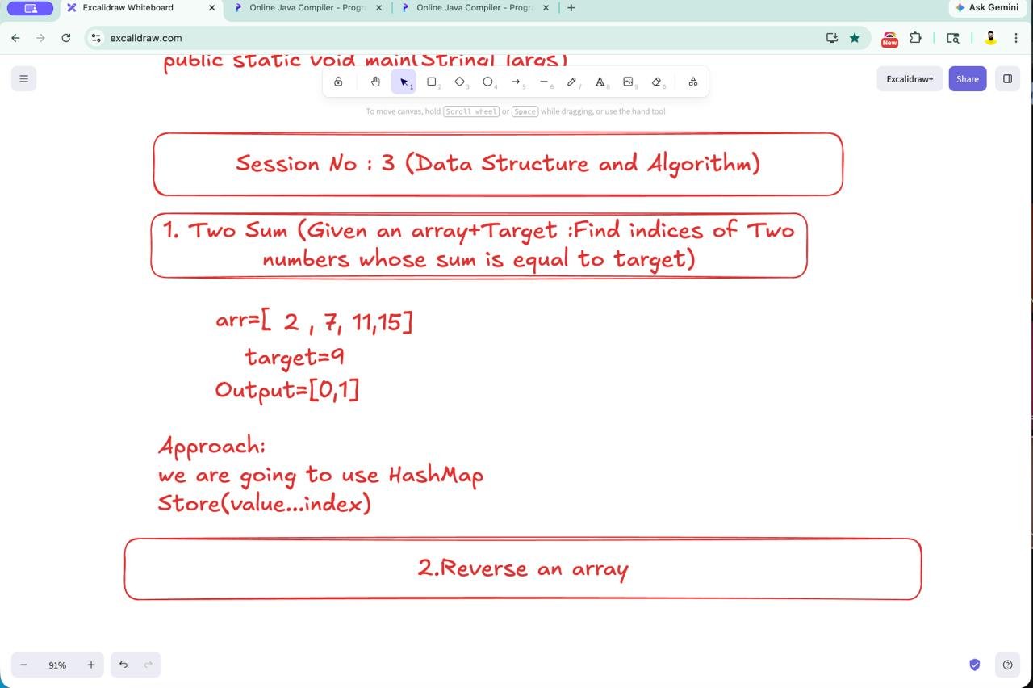

Que: Max. Sum of Sub Array? Kadane’s Algo

Que: Reverse the LinkedList? 3 pointer.

////////////////////////////////////////////////////////////////////////////////////////////////////////////////////////////////// 09/04/2026
class Animal{
void eat(){
System.out.println("Animal is eating");
}
}
class Dog extends Animal{
void bark(){
System.out.println("Dog is Barking");
}
}

class Main {
public static void main(String[] args) {
// System.out.println("Try programiz.pro");
Dog d=new Dog();
d.eat();
d.bark();
}
}
// Multi Level Inheritance:
class Animal{
void eat(){
System.out.println("Animal is eating");
}
}
class Dog extends Animal{
void bark(){
System.out.println("Dog is Barking");
}
}
class Puppy extends Dog{
void weep(){
System.out.println("puppy weeps");
}
}

class Main {
public static void main(String[] args) {
System.out.println("Try programiz.pro");
Puppy p=new Puppy();
p.eat();
p.bark();
p.weep();
}
}

// Online Java Compiler
// Use this editor to write, compile and run your Java code online
class Animal{
void eat(){
System.out.println("Animal is eating");
}
}
class Dog extends Animal{
void bark(){
System.out.println("Dog is Barking");
}
}
class cat extends Animal{
void meow(){
System.out.println("Cat meaowwwwwww");
}
}

class Main {
public static void main(String[] args) {
System.out.println("Try programiz.pro");
Dog d=new Dog();
cat c=new cat();
d.bark();
d.eat();
c.meow();
}
}

// Online Java Compiler
// Use this editor to write, compile and run your Java code online
class add{
int sum(int a,int b){
return a+b;
}
int sum(int a,int b,int c){
return a+b+c;
}
}

class Main {
public static void main(String[] args) {
System.out.println("Try programiz.pro");
add a=new add();
System.out.println(a.sum(2,3));
System.out.println(a.sum(2,2,2));
}
}

